**Weekly Change in Settlement (Bps)**

The following histograms illustrate the daily change in settlement of ED futures in the past 5 years.

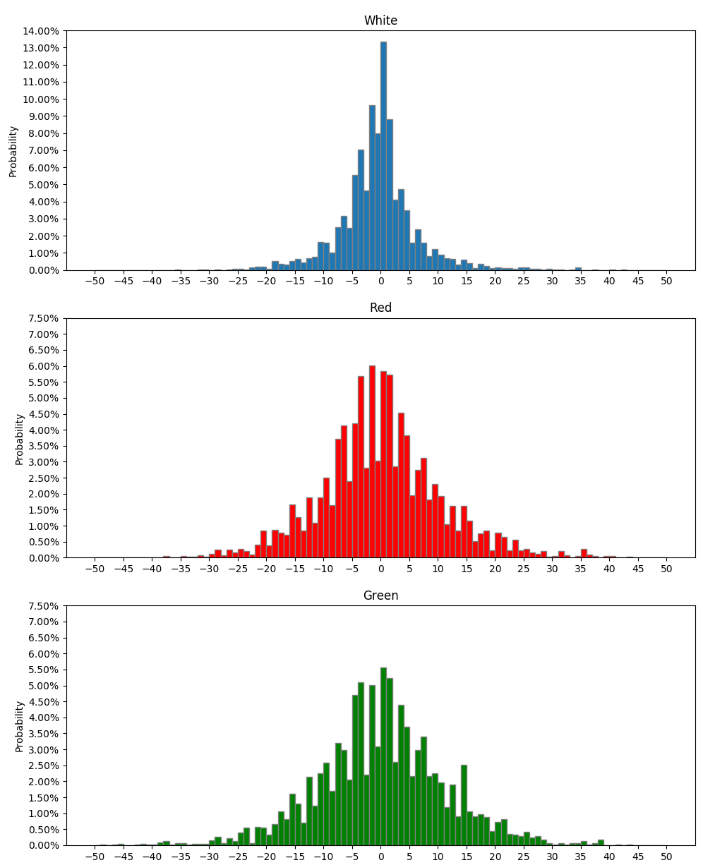

|  |  |  |  |
| --- | --- | --- | --- |
|  | White | Red | Green |
| Between -5bp to 5bp | 69.27% | 44.53% | 41.61% |
| Less than -5bp | 17.46% | 28.74% | 28.29% |
| Less than -10bp | 6.73% | 14.36% | 15.79% |
| Less than -15bp | 2.56% | 7.40% | 8.14% |
| Less than -20bp | 0.76% | 2.97% | 3.67% |
| More than 5bp | 13.27% | 26.72% | 30.10% |
| More than 10bp | 5.72% | 14.78% | 17.14% |
| More than 15bp | 2.52% | 7.71% | 8.65% |
| More than 20bp | 1.28% | 4.18% | 4.39% |
| Average move | -0.4557bp | 0.0077bp | 0.2448bp |